Ex:No: 17
HIGH LEVEL PROGRAMMING EXTENSIONS-FUNCTIONS

Aim:
To implement Functions using program in MySQL.
Problem 1:
Create a function that returns the level of a customer based on credit limit.
(Use the IF statement to determine the credit limit).
If credit limit > 50000 then customer_level = PLATINUM
If credit limit >= 10000 AND credit limit <= 50000 then customer_level = GOLD If credit limit credit limit < 10000 then customer_level = SILVER
RECURSION in Mysql Procedures
Mysql version should be >= 5.
Have to set system parameters. This means putting the recursion count limit. SET @@GLOBAL.max_sp_recursion_depth = 255;
SET @@session.max_sp_recursion_depth = 255;
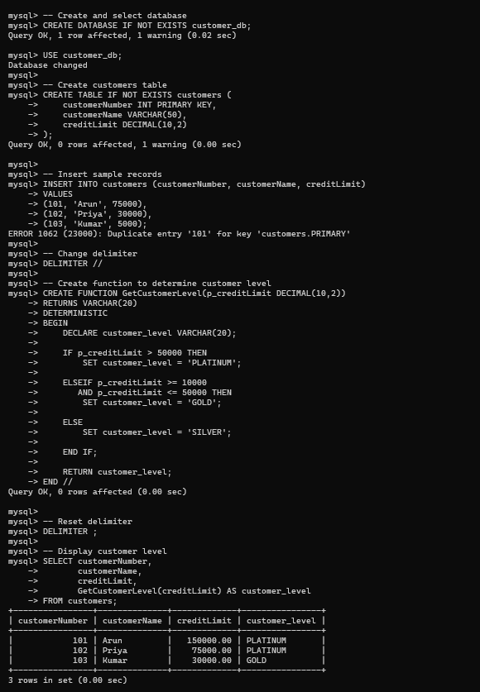

Problem 2
Write a recursive MySQL procedure compute the factorial of a number .
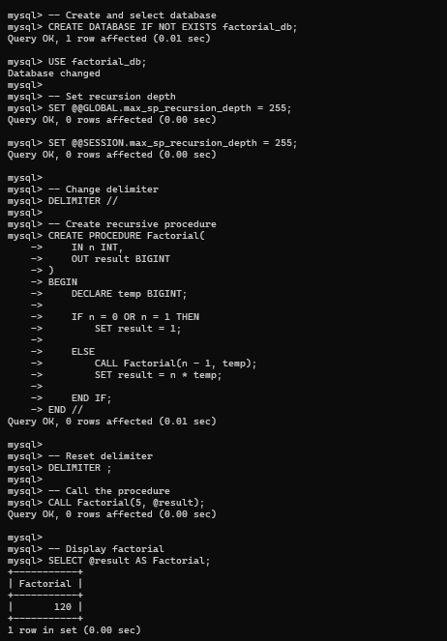

RESULT: Thus the Functions using program in MySQL executed successfully .

